Lab #5

Task #9:

#include<iostream>

using namespace std;

int main()

{

char oper;

int num1, num2;

cout << "Enter the first Number " << endl;

cin >> num1;

cout << "Enter the second Number ";

cin >> num2;

cout << "Enter the operator =";

cin >> oper;

switch (oper)

{

case '+':

cout << "THe sum of First&second NUmber is " << num1 + num2 << endl;

break;

case '-':

cout << "The Subtraction of two Numbers is " << num1 - num2 << endl;

break;

case '/':

cout << "The division of two NUmbers is " << num1 / num2 << endl;

break;

case '*':

cout << "The Multiplication of Two Numbers is " << num1*num2 << endl;

break;

}

system("pause");

return 0;

# }

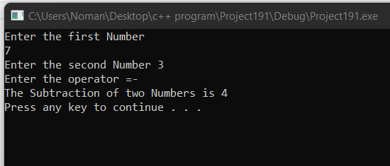  
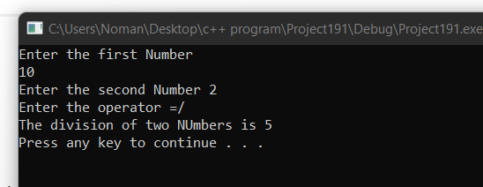

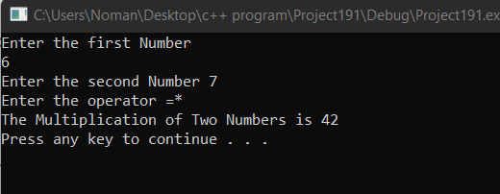

**Task #10**

#include<iostream>

using namespace std;

int main()

{

int num1, num2, num3, larger;

cout << "Enter the Number " << endl;

cin >> num1;

cout << "Enter the Second Number " << endl;

cin >> num2;

cout << "Enter the Third Number " << endl;

cin >> num3;

if (num1 > num2&&num1 > num3)

{

cout << "Large: " << num1 << endl;

if (num2 > num3)

{

cout << "Second Large: " << num2 << endl;

cout << "third Large: " << num3 << endl;

}

else

{

cout << "Second Large: " << num3 << endl;

cout << "third Large: " << num2<< endl;

}

}

else if (num2 > num1&&num2 > num3)

{

cout << "Large: " << num2 << endl;

if (num1 > num3)

{

cout << "Second Large: " << num1 << endl;

cout << "third Large: " << num3 << endl;

}

else

{

cout << "Second Large: " << num3 << endl;

cout << "third Large: " << num1 << endl;

}

}

else

{

cout << "Large: " << num3 << endl;

if (num1 > num2)

{

cout << "Second Large: " << num1 << endl;

cout << "third Large: " << num2 << endl;

}

else

{

cout << "Second Large: " << num2 << endl;

cout << "third Large: " << num1 << endl;

}

}

system("pause");

return 0;}

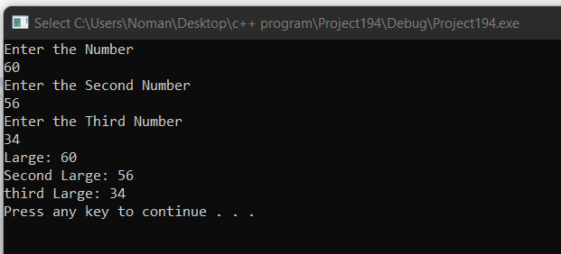

Task #12

#include<iostream>

using namespace std;

int main()

{

int units,result,result2=0;

float result1=0.0;

cout << "Enter the units which are consumed" << endl;

cin >> units;

if (units<=100)

{

result= units * 6;

cout << "The Bill of Month is " << result << endl;

}

else if (units > 100 &&units <= 300)

{

result1 = float(units*7.5 + result1/ 10);

cout << "The Bill of the Month is " << result1 << endl;

}

else if (units > 300)

{

result2 = units * 9 + result2 / 20;

cout << "The Bill of the Month is " << result2 << endl;

}

system("pause");

return 0;

}

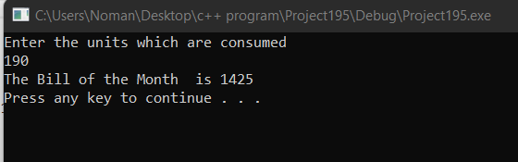

Task #11

#include<iostream>

using namespace std;

int main()

{

char membership;

int age;

cout << "Enter M or m for membership and n or N for non-membership : ";

cin >> membership;

cout << "Enter age : ";

cin >> age;

if (age < 65 && (membership == 'm' || membership == 'M'))

{

cout << "$10 : Club member less than 65 years";

}

if (age == 65 && (membership == 'm' || membership == 'M'))

{

cout << "$5 : Club member at least 65 years";

}

if (membership == 'n' || membership == 'N')

{

cout << "$20 : Non-member : ";

}

system("pause");

return 0;

}

